Name | Priyanka H. Dhakate
Class | SY IT(A)
PRN | 124B1F145
Batch | A4

-: Assignment 4: -
Write code to implement Procedure and Function.
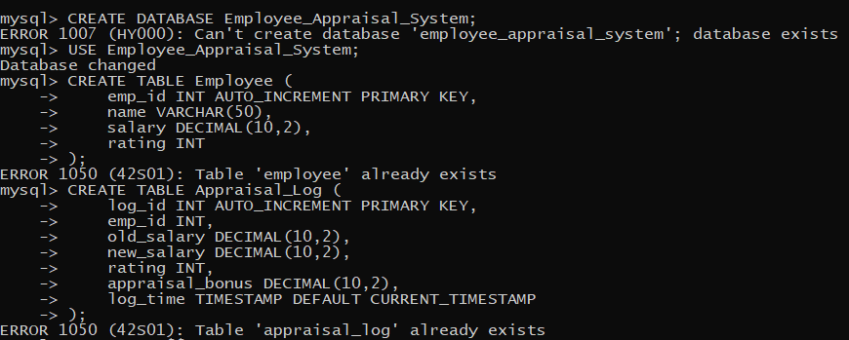
- Insert procedure to get add employee
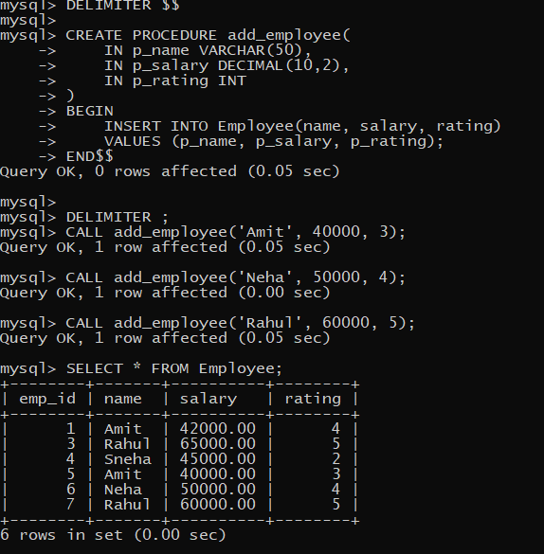

- Update procedure to get updated employee
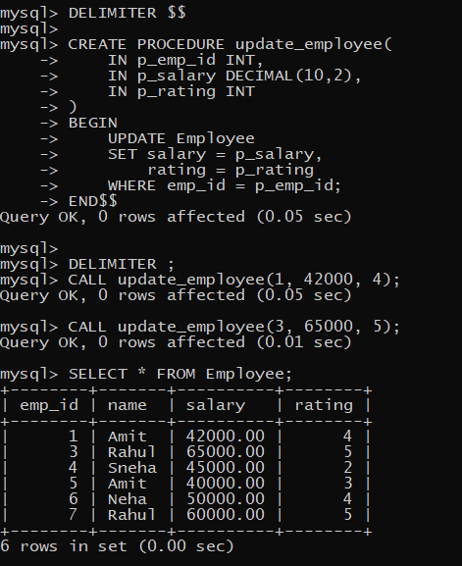

- Delete procedure to get delete that employee
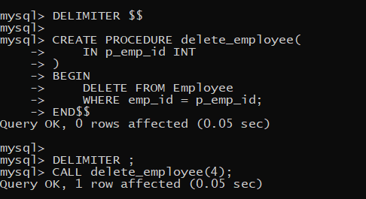
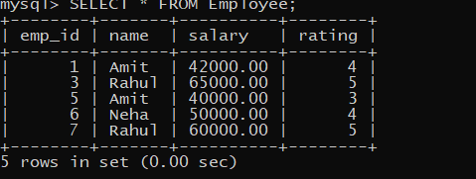

- Procedure to calculate Total Salary
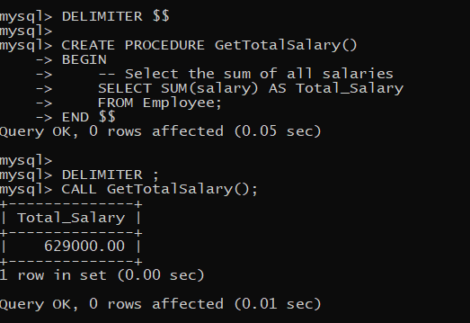

- Function to get Salary

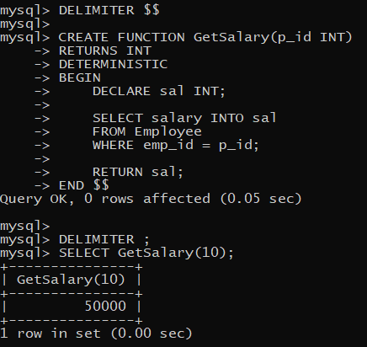

- Function to get Rating
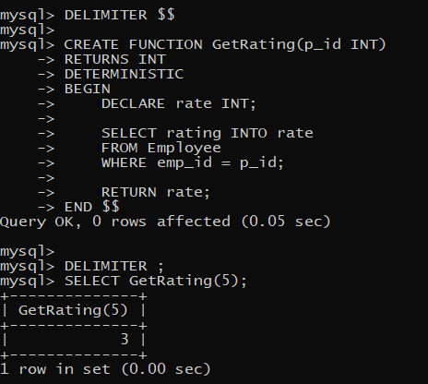

- Function to calculate Bonus
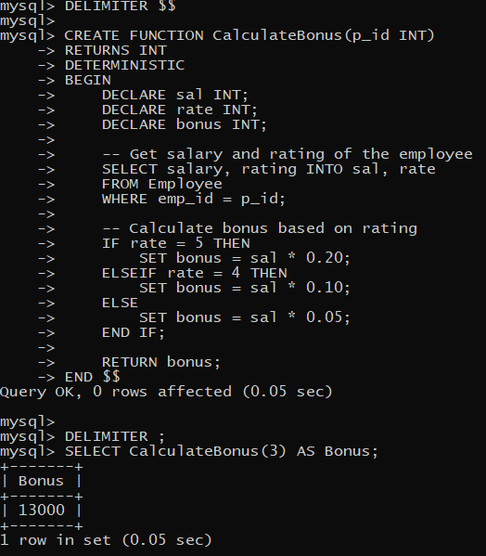

- Function to calculate Total Salary
